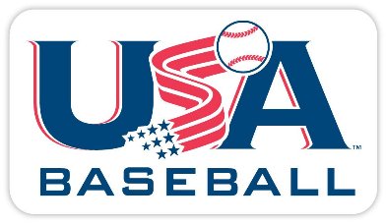
2024 Bat Rules

Coach Pitch/T-Ball (Ages 4-6): USA Baseball Stamped Bats and printed text “Only for use with approved t-balls.”

Baseball Ages (9-12) All bats must have a USA Baseball stamp to be approved for play. Only Exception BB-COR certified bats are also approved for play (drop -3 only). All stamped BPF 1.15 are not eligible for use.

If you have any questions all the approved bats for 2024 are on this link below.
USA Baseball Approved Bat List: https://usabat.com/

Softball (Ages 7-12)
The bat shall be no more than thirty-four inches (34”) long and not more than two and one-fourth inches (21/4”) in diameter at its largest part. The bat, in its entirety, shall not exceed thirty-eight ounces (38 oz.) in weight. The bat shall have a safety grip of cork, tape, or composition material. The safety grip shall not be less than ten inches (10”) long and shall not extend more than fifteen inches (15”) from the small end of the bat.
- Approved 2024 Dixie Softball bat manufacturers as of November 30, 2023 are: DeMARINI, LOUISVILLE SLUGGER, MARUCCI SPORTS, MIZUNO USA.

